# Status Report # 5

Report Date

February 19, 2016

Progress Overview

During this period we completed all remaining tasks for the project. We focused mainly on the website and the desktop client during this period, but all finished the upload and download endpoints in the API.

During this period we also set up a server to host the final copy of our project, in preparation for live demos.

As of this status report the project is officially over, however we many continue to work on it some in our free time.

Budget Overview

## Cost Overview as of February 19, 2016

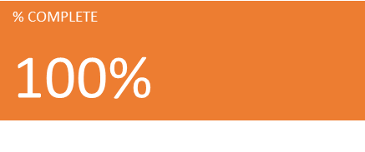

Outstanding Issues/Purposed Solutions

There are no issues to report as of this status update.

Change Requests

There are currently no pending or active change requests.

Plans For Next Period

There are no plans for any further work or periods on this project. As of February 19th all desired system requirements have been met and the project is considered completed.